# Appendix B: Multi-City Evaluation Applied to New York Metropolitan Area

We applied the model to predict the contributions to ridership change for the New York MSA, which was not included in the model estimation or in the results reported previously. Between 2012 and 2018, the model estimates New York bus ridership to decrease 9.5% due to ride-hailing, 6.7% due to higher fares, and 3.2% due to lower gas prices, with the remaining factors contributing no more than 1.2% each to bus ridership change. Between 2012 and 2018, the model estimates New York rail ridership to increase 1.9% due to more service and to decrease 3.3% due to lower gas prices and 2.8% due to higher fares. The remaining factors contribute no more than 1.2% each to rail ridership change. Transit ridership in New York outperforms these expectations, with observed bus ridership decreasing 9.4% compared to a 19.4% predicted decrease, and observed rail ridership increasing 3.4% compared to a 3.5% predicted decrease. New York transit ridership may be less elastic to the factors driving change elsewhere—regardless of gas prices, fares, or the availability of competing modes, transit may remain the only practical option for many travelers. Given that New York is a unique transit market representing over 20% of bus ridership and over 60% of rail ridership in the US, further study is warranted to better understand the local factors driving ridership changes there.

The tables and charts below show these application results.

|  |  |  |  |  |  |
| --- | --- | --- | --- | --- | --- |
| **New York-Northern New Jersey-Long Island, NY-NJ-PA Metro Area-Bus** | | | | | |
|  |  |  |  |  |  |
|  | **Average Values** | | | **Ridership Effect** | |
| **Description** | **2012** | **2018** | **% Diff** | **Absolute** | **% Diff** |
|  |  |  |  |  |  |
| **Vehicle Revenue Miles** | 227,959,420 | 230,662,400 | 1.2% | 5,665,220 | **28.5%** |
| **Average Fare (2018$)** | 1.37 | 1.72 | 25.9% | -81,058,050 | **-407.2%** |
| **Network Restructure** | - | - | - | - | **0.0%** |
| **Major Maintenance Event** | - | - | - | - | **0.0%** |
| **Population + Employment** | 27,909,100 | 29,807,700 | 6.8% | 14,647,140 | **73.6%** |
| **Share of Population and Employment in Transit Supportive Density** | 0.71 | 0.71 | 1.0% | 3,038,090 | **15.3%** |
| **Average Gas Price (2018$)** | 4.11 | 2.92 | -28.9% | -38,706,840 | **-194.4%** |
| **Median Per Capita Income (2018$)** | 33,960 | 36,800 | 8.4% | -5,590,880 | **-28.1%** |
| **% of Households with 0 Vehicles** | 32 | 30 | -4.8% | -3,085,640 | **-15.5%** |
| **% Working at Home** | 4.1 | 4.6 | 12.2% | -3,775,540 | **-19.0%** |
| **Years Since Ride-hail Start** | 1.0 | 7 | 6 | -115,779,640 | **-581.6%** |
| **Bike Share** | - | 1 | 1 | - 11,132,940 | **-55.9%** |
| **Electric Scooters** | - | - | - | - | **0.0%** |
| **New Reporters** |  |  |  | - | **0.0%** |
| **Total Modeled Ridership** | 19,908,240 | 15,724,208 | -21.02% | -4184032.512 | **-21.0%** |
| **Total Observed Ridership** | 1,032,661,299 | 935,808,063 | -9.38% | -96853236 | **-9.4%** |
| **Unexplained Change** |  |  |  |  | **11.6%** |

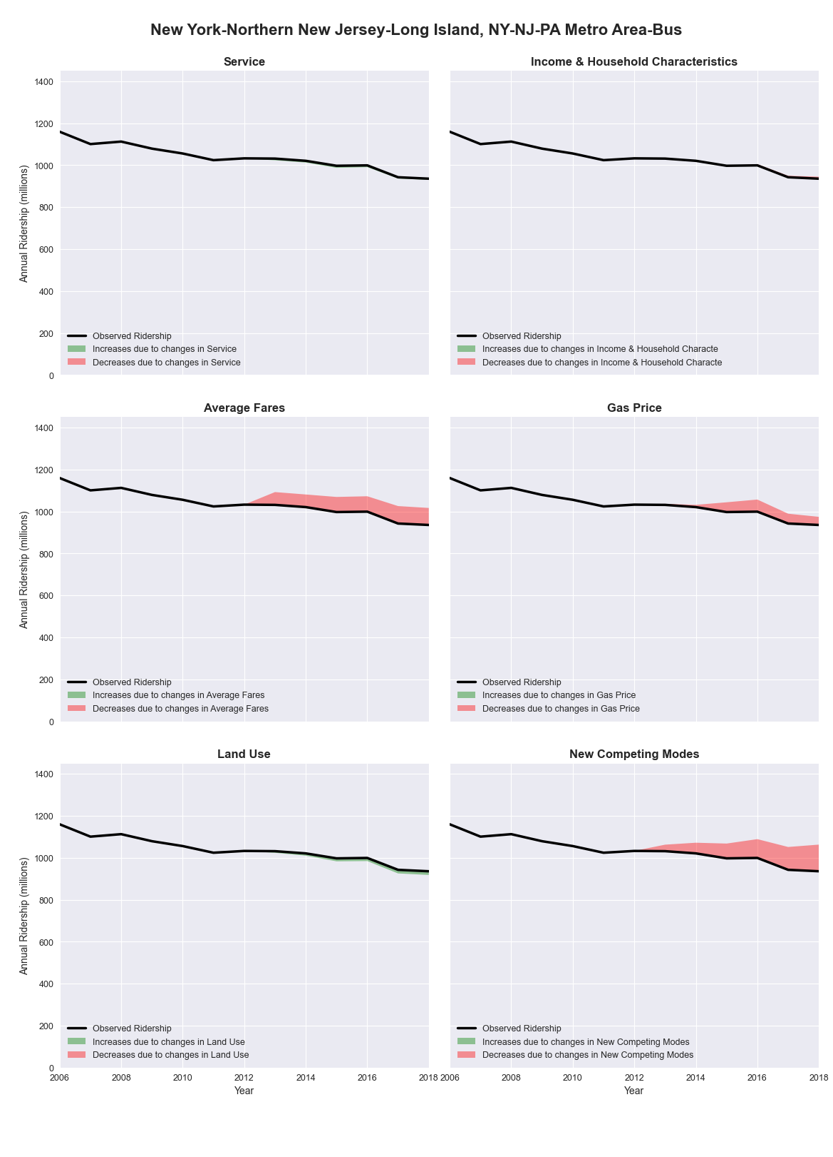

|  |  |  |  |  |  |
| --- | --- | --- | --- | --- | --- |
| **New York-Northern New Jersey-Long Island, NY-NJ-PA Metro Area-Rail** | | | | | |
|  |  |  |  |  |  |
|  | **Average Values** | | | **Ridership Effect** | |
| **Description** | **2012** | **2018** | **% Diff** | **Absolute** | **% Diff** |
|  |  |  |  |  |  |
| **Vehicle Revenue Miles** | 542,311,530 | 560,645,660 | 3.4% | 65,671,840 | **2.6%** |
| **Average Fare (2018$)** | 1.70 | 1.96 | 15.3% | -97,086,260 | **-3.9%** |
| **Network Restructure** | - | - | - | - | **0.0%** |
| **Major Maintenance Event** | - | - | - | - | **0.0%** |
| **Population + Employment** | 27,909,100 | 29,807,700 | 6.8% | 43,188,240 | **1.7%** |
| **Share of Population and Employment in Transit Supportive Density** | 0.71 | 0.71 | 1.0% | 9,008,500 | **0.4%** |
| **Average Gas Price (2018$)** | 4.11 | 2.92 | -28.9% | -115,124,430 | **-4.6%** |
| **Median Per Capita Income (2018$)** | 33,960 | 36,800 | 8.4% | -17,647,060 | **-0.7%** |
| **% of Households with 0 Vehicles** | 32 | 30 | -4.8% | -8,775,160 | **-0.3%** |
| **% Working at Home** | 4.1 | 4.6 | 12.2% | -11,520,790 | **-0.5%** |
| **Years Since Ride-hail Start** | 1.0 | 7 | 6 | 39,927,810 | **1.6%** |
| **Bike Share** | - | 1 | 1 | - 31,582,430 | **-1.3%** |
| **Electric Scooters** | - | - | - | - | **0.0%** |
| **New Reporters** |  |  |  | - | **0.0%** |
| **Total Modeled Ridership** | 2,509,543,465 | 2,409,370,027 | -3.99% | -100173438.3 | **-4.0%** |
| **Total Observed Ridership** | 2,929,500,931 | 3,028,681,761 | 3.39% | 99180830 | **3.4%** |
| **Unexplained Change** |  |  |  |  | **7.4%** |

